<https://www.interviewbit.com/angular-interview-questions/>

**1. Why were client-side frameworks like Angular introduced?**

Back in the day, web developers used VanillaJS and jQuery to develop dynamic websites but, as the logic of one's website grew, the code became more and more tedious to maintain. For applications that use complex logic, developers had to put in extra effort to maintain separation of concerns for the app. Also, jQuery did not provide facilities for data handling across views.  
For tackling the above problems, client-side frameworks like Angular came into the picture, which made life easier for the developers by handling separation of concerns and dividing code into smaller bits of information (In the case of Angular, called Components).  
Client-side frameworks allow one to develop advanced web applications like Single-Page-Application. Not that we cannot develop SPAs using VanillaJS, but by doing so, the development process becomes slower.

**2. How does an Angular application work?**

Every Angular app consists of a file named **angular.json**. This file will contain all the configurations of the app. While building the app, the builder looks at this file to find the entry point of the application. Following is an image of the angular.json file:

"build": {

"builder": "@angular-devkit/build-angular:browser",

"options": {

"outputPath": "dist/angular-starter",

"index": "src/index.html",

"main": "src/main.ts",

"polyfills": "src/polyfills.ts",

"tsConfig": "tsconfig.app.json",

"aot": false,

"assets": [

"src/favicon.ico",

"src/assets"

],

"styles": [

"./node_modules/@angular/material/prebuilt-themes/deeppurple-amber.css",

"src/style.css"

]

}

}

Inside the build section, the main property of the options object defines the entry point of the application which in this case is **main.ts**.  
The main.ts file creates a browser environment for the application to run, and, along with this, it also calls a function called **bootstrapModule**, which bootstraps the application. These two steps are performed in the following order inside the main.ts file:

import { platformBrowserDynamic } from '@angular/platform-browser-dynamic';

platformBrowserDynamic().bootstrapModule(AppModule)

In the above line of code, **AppModule** is getting bootstrapped.  
The AppModule is declared in the app.module.ts file. This module contains declarations of all the components.  
Below is an example of app.module.ts file:

import { BrowserModule } from '@angular/platform-browser';

import { NgModule } from '@angular/core';

import { AppComponent } from './app.component';

@NgModule({

declarations: [

AppComponent

],

imports: [

BrowserModule

],

providers: [],

entryComponents: [],

bootstrap: [AppComponent]

})

export class AppModule { }

As one can see in the above file, **AppComponent** is getting bootstrapped.  
This component is defined in **app.component.ts** file. This file interacts with the webpage and serves data to it.  
Below is an example of app.component.ts file:

import { Component } from '@angular/core';

@Component({

selector: 'app-root',

templateUrl: './app.component.html',

styleUrls: ['./app.component.css']

})

export class AppComponent {

title = 'angular';

}

Each component is declared with three properties:  
1. **Selector** - used for accessing the component  
2. **Template/TemplateURL** - contains HTML of the component  
3. **StylesURL** - contains component-specific stylesheets  
  
After this, Angular calls the **index.html** file. This file consequently calls the root component that is **app-root**. The root component is defined in **app.component.ts**.  
This is how the index.html file looks:

<!doctype html>

<html lang="en">

<head>

<meta charset="utf-8">

<title>Angular</title>

<base href="/">

<meta name="viewport" content="width=device-width, initial-scale=1">

</head>

<body>

<app-root></app-root>

</body>

</html>

The HTML template of the root component is displayed inside the <app-root> tags.  
  
This is how every angular application works.

**3. What are some of the advantages of Angular over other frameworks?**

• **Features that are provided out of the box -** Angular provides a number of built-in features like,routing, state management, rxjs library and http servicesstraight out of the box. This means that one does not need tolook for the above stated features separately. They are allprovided with angular.

• **Declarative UI -**Angular uses HTML to render the UI of an application. HTML isa declarative language and is much easier to use than JavaScript.

• **Long-term Google support -**Google announced Long-term support for Angular. This means that Google plans to stick with Angular and further scale up its ecosystem.

**4. List out differences between AngularJS and Angular**

**Architecture**

AngularJS uses MVC or Model-View-Controller architecture, where the Model contains the business logic, Controller processes information and View shows the information present in the Model.  
Angular replaces controllers with Components. Components are nothing but directives with a predefined template.

**Language**

AngularJS uses JavaScript language, which is a dynamically typed language.  
Angular uses TypeScript language, which is a statically typed language and is a superset of JavaScript. By using statically typed language, Angular provides better performance while developing larger applications.

**Mobile Support**

AngularJS does not provide mobile support.  
Angular is supported by all popular mobile browsers.

**Structure**

While developing larger applications, the process of maintaining code becomes tedious in the case of AngularJS.  
In the case of Angular, it is easier to maintain code for larger applications as it provides a better structure.

**Expression Syntax**

While developing an AngularJS application, a developer needs to remember the correct ng-directive for binding an event, or a property. Whereas in Angular, property binding is done using "[ ]" attribute and event binding is done using "( )" attribute.

**5. What is AOT compilation? What are the advantages of AOT?**

Every Angular application consists of components and templates which the browser cannot understand. Therefore, all the Angular applications need to be compiled first before running inside the browser.  
  
Angular provides two types of compilation:

• JIT(Just-in-Time) compilation

• AOT(Ahead-of-Time) compilation

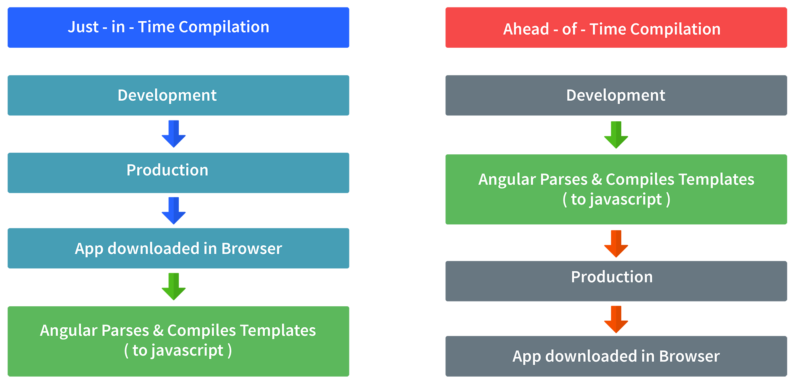

In JIT compilation, the application compiles inside the browser during runtime.  
Whereas in the AOT compilation, the application compiles during the build time.  
  
The advantages of using AOT compilation are:

• Since the application compiles before running inside the browser, the browser loads the executable code and renders the application immediately, which leads to **faster rendering**.

• In AOT compilation, the compiler sends the external HTML and CSS files along with the application, eliminating separate AJAX requests for those source files, which leads to **fewer ajax requests**.

• Developers can detect and handle errors during the building phase, which helps in **minimizing errors**.

• The AOT compiler adds HTML and templates into the JS files before they run inside the browser. Due to this, there are no extra HTML files to be read, which provide **better security** to the application.

By default, angular builds and serves the application using JIT compiler:

ng build  
ng serve

For using AOT compiler following changes should be made:

ng build --aot  
ng serve --aot

**6. Explain Components, Modules and Services in Angular**

For better understanding, I would like you to create an Angular application by running the following inside the command terminal:

ng new angularApp

The above command will create an angular application in the directory.  
Next, let's move on to understand Components, Modules, and Services.  
  
**Components**  
In Angular, components are the basic building blocks, which control a part of the UI for any application.  
A component is defined using the **@Component** decorator. Every component consists of three parts, the template which loads the view for the component, a stylesheet which defines the look and feel for the component, and a class that contains the business logic for the component.  
For creating a component, inside the command terminal, navigate to the directory of the application created, and run the following command:

ng generate component test

Or

ng g c test

One can see the generated component inside src/app/test folder. The component will be defined inside test.component.ts and this is how it looks:

import { Component, OnInit } from '@angular/core';

@Component({

selector: 'app-test',

templateUrl: './test.component.html',

styleUrls: ['./test.component.css']

})

export lass TestComponent implements OnInit {

constructor() {}

ngOnInit() {

}

}

As we can see in the above image, our component is defined with **@Component** decorator.

**Modules**  
A module is a place where we can group components, directives, services, and pipes. Module decides whether the components, directives, etc can be used by other modules, by exporting or hiding these elements. Every module is defined with a @NgModule decorator.  
By default, modules are of two types:

• Root Module

• Feature ModuleEvery application can have only one root module whereas, it can have one or more feature modules.  
A root module imports **BrowserModule**, whereas a feature module imports **CommonModule**.  
  
In the application that we created before, one can see that the root module is defined inside **app.module.ts** and this is how it looks:

import { BrowserModule } from '@angular/platform-browser';

import { NgModule } from '@angular/core';

import { AppComponent } from './app.component';

import { TestComponent } from './test/text.component';

@NgModule({

declarations: [

AppComponent,

TestComponent

],

imports: [

BrowserModule

],

providers: [],

bootstrap: [AppComponent]

})

export class AppModule { }

We can see in the above image that the component we created earlier is already imported in the declarations array.  
  
To create a feature module, run the following command:

ng g m test-module

The module is created inside the src/app/test-module/test-module.module.ts file:

import { NgModule } from '@angular/core';

import { CommonModule } from '@angular/common';

@NgModule({

declarations: [],

imports: [

CommonModule

]

})

export class TestModuleModule { }

As one can see, **CommonModule** is imported since this is a feature module.

**Services** Services are objects which get instantiated only once during the lifetime of an application. The main objective of a service is to share data, functions with different components of an Angular application.  
A service is defined using a **@Injectable** decorator. A function defined inside a service can be invoked from any component or directive.  
  
To create a service, run the following command:

ng g s test-service

The service will be created inside src/app/test-service.service.ts:

import { Injectable } from '@angular/core';

@Injectable({

providedIn: 'root'

})

export class TestServiceService {

constructor() { }

}

Any method/function defined inside the TestServiceService class can be directly used inside any component by just importing the service.

**7. What are lifecycle hooks in Angular? Explain a few lifecycle hooks.**

Every component in Angular has a lifecycle, different phases it goes through from the time of creation to the time it's destroyed. Angular provides **hooks** to tap into these phases and trigger changes at specific phases in a lifecycle.

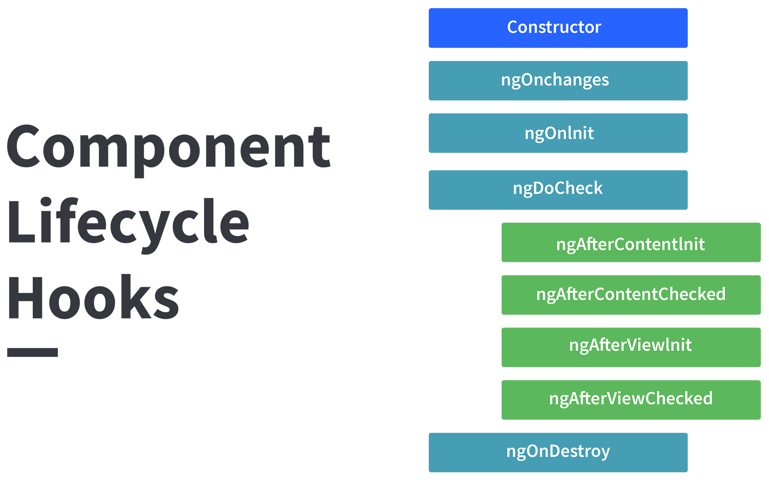

**ngOnChanges( )** This hook/method is called before **ngOnInit** and whenever one or more input properties of the component changes.  
This method/hook receives a SimpleChanges object which contains the previous and current values of the property.  
  
**ngOnInit( )** This hook gets called once, after the **ngOnChanges** hook.  
It initializes the component and sets the input properties of the component.  
  
**ngDoCheck( )** It gets called after **ngOnChanges** and **ngOnInit** and is used to detect and act on changes that cannot be detected by Angular.  
We can implement our change detection algorithm in this hook.

**ngAfterContentInit( )** It gets called after the first **ngDoCheck** hook. This hook responds after the content gets projected inside the component.  
  
**ngAfterContentChecked( )** It gets called after **ngAfterContentInit** and every subsequent **ngDoCheck**. It responds after the projected content is checked.  
  
**ngAfterViewInit( )** It responds after a component's view, or a child component's view is initialized.  
  
**ngAfterViewChecked( )** It gets called after **ngAfterViewInit**, and it responds after the component's view, or the child component's view is checked.  
  
**ngOnDestroy( )** It gets called just before Angular destroys the component. This hook can be used to clean up the code and detach event handlers.  
  
Let’s understand how to use **ngOnInit** hook, since it’s the most oftenly used hook. If one has to process lot of data during component creation, it’s better to do it inside **ngOnInit** hook rather than the constructor:

import { Component, OnInit } from '@angular/core';

@Component({

selector: 'app-test',

templateUrl: './test.component.html',

styleUrls: ['./test.component.css']

})

export class TestComponent implements OnInit {

constructor() { }

ngOnInit() {

this.processData();

}

processData(){

// Do something..

}

}

As you can see we have imported OnInit but we have used **ngOnInit** function. This principle should be used with the rest of the hooks as well.

**8. Explain string interpolation and property binding in Angular.**

String interpolation and property binding are parts of **data-binding** in Angular.  
Data-binding is a feature in angular, which provides a way to communicate between the component(Model) and its view(HTML template).  
Data-binding can be done in two ways, **one-way** binding and **two-way** binding.  
In Angular, data from the component can be inserted inside the HTML template. In one-way binding, any changes in the component will directly reflect inside the HTML template but, vice-versa is not possible. Whereas, it is possible in two-way binding.  
  
String interpolation and property binding allow only one-way data binding.  
String interpolation uses the double curly braces **{{ }}** to display data from the component. Angular automatically runs the expression written inside the curly braces, for example, {{ 2 + 2 }} will be evaluated by Angular and the output 4, will be displayed inside the HTML template. Using property binding, we can bind the DOM properties of an HTML element to a component's property. Property binding uses the square brackets **[ ]** syntax.

**9. How are Angular expressions different from JavaScript expressions?**

The first and perhaps, the biggest difference is that Angular expressions allow us to write JavaScript in HTML which is not the case when it comes to JavaScript expressions.  
Next, Angular expressions are evaluated against a **local** scope object whereas JavaScript expressions against **global** window object. Let's understand that better with an example :  
  
Consider the following component named test:

import { Component, OnInit } from '@angular/core';

@Component({

selector: 'app-test',

template: `

<h4>{{message}}</h4>

`,

styleUrls: ['./test.component.css']

})

export class TestComponent implements OnInit {

message:string = “Hello world”;

constructor() { }

ngOnInit() {

}

}

As one can see that Angular expression is used to display **message** property of a component. Since we are using Angular expressions, in the present template, we cannot access a property outside of its local scope, which in this case is **TestComponent**.  
This proves that Angular expressions are always evaluated based on **scope** object rather than the global object.  
  
Next difference is how Angular expressions handle **null** and **undefined**.  
Consider the following JavaScript example:

<!DOCTYPE html>

<html lang="en">

<head>

<meta charset="UTF-8">

<meta name="viewport" content="width=device-width, initial-scale=1.0">

<title>JavaScript Test</title>

</head>

<body>

<div id="foo"><div>

</body>

<script>

'use strict';

let bar = {};

document.getElementById('foo').innerHTML = bar.x;

</script>

</html>

If you run the above code, you will see **undefined** displayed on the screen. Although it’s not ideal to leave any property undefined, the user does not need to see this.  
Now consider the following Angular example:

import { Component, OnInit } from '@angular/core';

@Component({

selector: 'app-new',

template: `

<h4>{{message}}</h4>

`,

styleUrls: ['./new.component.css']

})

export class NewComponent implements OnInit {

message:object = {};

constructor() { }

ngOnInit() {

}

}

If you render the above component, you will **not** see undefined being displayed on the screen.  
  
Next, in Angular expressions one **cannot** use loops, conditionals and exceptions.  
  
The difference which makes Angular expressions quite beneficial is the use of **pipes**. Angular uses pipes(called filters in AngularJS), which can be used to format data before displaying it. Let’s see one predefined pipe in action:

import { Component, OnInit } from '@angular/core';

@Component({

selector: 'app-new',

template: `

<h4>{{message | lowercase}}</h4>

`,

styleUrls: ['./new.component.css']

})

export class NewComponent implements OnInit {

message:string = "HELLO WORLD";

constructor() { }

ngOnInit() {

}

}

In the above code we have used a predefined pipe called **lowercase**, which transforms all the letters in lowercase. Therefore, if you render the above component, you will see “hello world” being displayed.  
  
In contrast, JavaScript does not have the concept of **pipes**.

**10. How are observables different from promises?**

The first difference is that an Observable is **lazy** whereas a Promise is **eager**.

|  |  |
| --- | --- |
| Promise | Observable |
| Emits a single value | Emits multiple values over a period of time |
| Not Lazy | Lazy. An observable is not called until we subscribe to the observable |
| Cannot be cancelled | Can be cancelled by using the unsubscribe() method |
|  | Observable provides operators like map, forEach, filter, reduce, retry, retryWhen etc. |

Consider the following Observable:

const observable = rxjs.Observable.create(observer => {

console.log('Text inside an observable');

observer.next('Hello world!');

observer.complete();

});

console.log('Before subscribing an Observable');

observable.subscribe((message)=> console.log(message));

When you run the above Observable, you can see messages being displayed in the following order:

Before subscribing an Observable  
Text inside an observable  
Hello world!

As you can see, observables are lazy. Observable runs only when someone subscribes to them hence, the message “Before subscribing…” is displayed ahead of the message inside the observable.  
  
Now let’s consider a Promise:

const promise = new Promise((resolve, reject) => {

console.log('Text inside promise');

resolve('Hello world!');

});

console.log('Before calling then method on Promise');

greetingPoster.then(message => console.log(message));

Running the above promise, the messages will be displayed in the following order:

Text inside promise  
Before calling then method on Promise  
Hello world!

As you can see the message inside Promise is displayed first. This means that a promise runs before the **then** method is called. Therefore, promises are **eager**.  
  
The next difference is that Promises are always **asynchronous**. Even when the promise is immediately resolved. Whereas an Observable, can be both **synchronous** and **asynchronous**.  
  
The above example of an observable is the case to show that an observable is synchronous. Let’s see the case where an observable can be asynchronous:

const observable = rxjs.Observable.create(observer => {

setTimeout(()=>{

observer.next('Hello world');

observer.complete();

},3000)

});

console.log('Before calling subscribe on an Observable');

observable.subscribe((data)=> console.log(data));

console.log('After calling subscribe on an Observable');

The messages will be displayed in the following order:

Before calling subscribe on an Observable  
After calling subscribe on an Observable  
Hello world!

You can see in this case, observable runs asynchronously.  
  
The next difference is that Observables can emit **multiple** values whereas Promises can emit only one value.  
  
The biggest feature of using observables is the use of **operators**. We can use multiple operators on an observable whereas, there is no such feature in a promise.

**11. Angular by default, uses client-side rendering for its applications.**

Can one make an angular application to render on the server-side?  
Yes, angular provides a technology called **Angular Universal**, which can be used to render applications on the server-side.  
  
The advantages of using Angular Universal are :

• First time users can instantly see a view of the application. This benefits in providing **better user experience**.

• Many search engines expect pages in plain HTML, thus, Universal can make sure that your content is available on every search engine, which leads to **better SEO**.

• Any server-side rendered application **loads faster** since rendered pages are available to the browser sooner.

**12. What are directives in Angular?**

A directive is a class in Angular that is declared with a **@Directive** decorator.  
Every directive has its own behaviour and can be imported into various components of an application.  
  
**When to use a directive?**  
Consider an application, where multiple components need to have similar functionalities. The norm thing to do is by adding this functionality individually to every component but, this task is tedious to perform. In such a situation, one can create a **directive** having the required functionality and then, import the directive to components which require this functionality.  
  
**Types of directives**  
**Component directives**  
These form the main class in directives. **Instead** of @Directive decorator we use **@Component** decorator to declare these directives. These directives have a view, a stylesheet and a selector property.  
  
**Structural directives**  
These directives are generally used to manipulate DOM elements.  
Every structural directive has a ‘ * ’ sign before them.  
We can apply these directives to any DOM element.  
  
Let’s see some built-in structural directives in action:

<div *ngIf="isReady" class="display_name">

{{name}}

</div>

<div class="details" *ngFor="let x of details" >

<p>{{x.name}}</p>

<p> {{x.address}}</p>

<p>{{x.age}}</p>

</div>

In the above example, we can *ngIf and *ngFor directives being used.  
  
*ngIf is used to check a boolean value and if it’s truthy,the div element will be displayed.  
  
*ngFor is used to iterate over a list and display each item of the list.  
  
**Attribute Directives**  
  
These directives are used to change the look and behaviour of a DOM element. Let’s understand attribute directives by creating one:  
  
How to create a custom directive?  
  
We’re going to create an attribute directive:  
  
In the command terminal, navigate to the directory of the angular app and type the following command to generate a directive:

ng g directive blueBackground

The following directive will be generated. Manipulate the directive to look like this:

import { Directive, ElementRef } from '@angular/core';

@Directive({

selector: '[appBlueBackground]'

})

export class BlueBackgroundDirective {

constructor(el:ElementRef) {

el.nativeElement.style.backgroundColor = "blue";

}

}

Now we can apply the above directive to any DOM element:

<p appBlueBackground>Hello World!</p>

**13. How does one share data between components in Angular?**

Following are the commonly used methods by which one can pass data between components in angular:

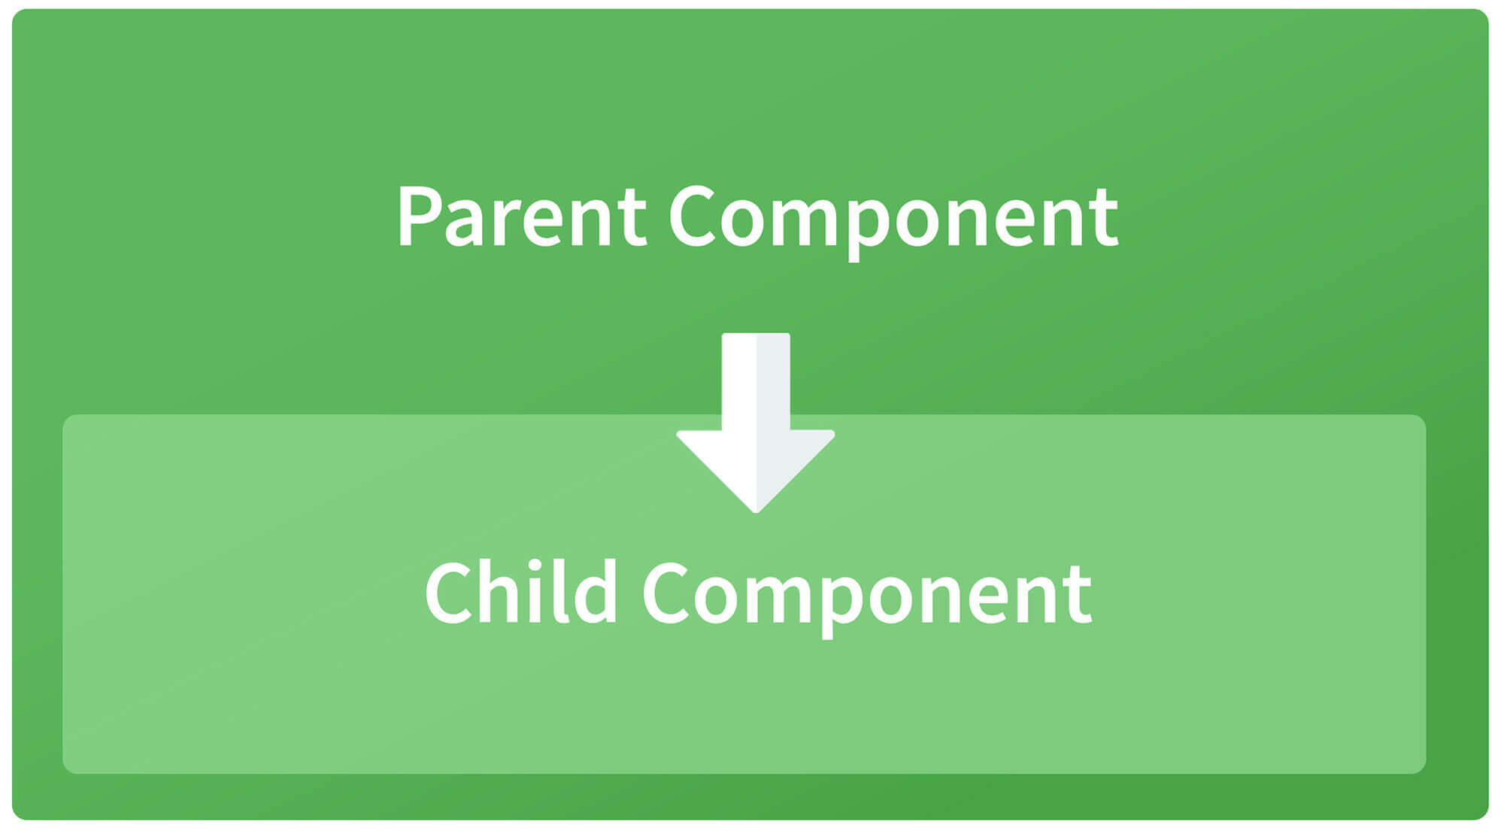

**Parent to child using @Input decorator**  
  
Consider the following parent component:

@Component({

selector: 'app-parent',

template: `

<app-child [data]=data></app-child>

` ,

styleUrls: ['./parent.component.css']

})

export class ParentComponent{

data:string = "Message from parent";

constructor() { }

}

In the above parent component, we are passing “data” property to the following child component:

import { Component, Input} from '@angular/core';

@Component({

selector: 'app-child',

template:`

<p>{{data}}</p>

`,

styleUrls: ['./child.component.css']

})

export class ChildComponent {

@Input() data:string

constructor() { }

}

In the child component, we are using @Input decorator to capture data coming from a parent component and using it inside the child component’s template.

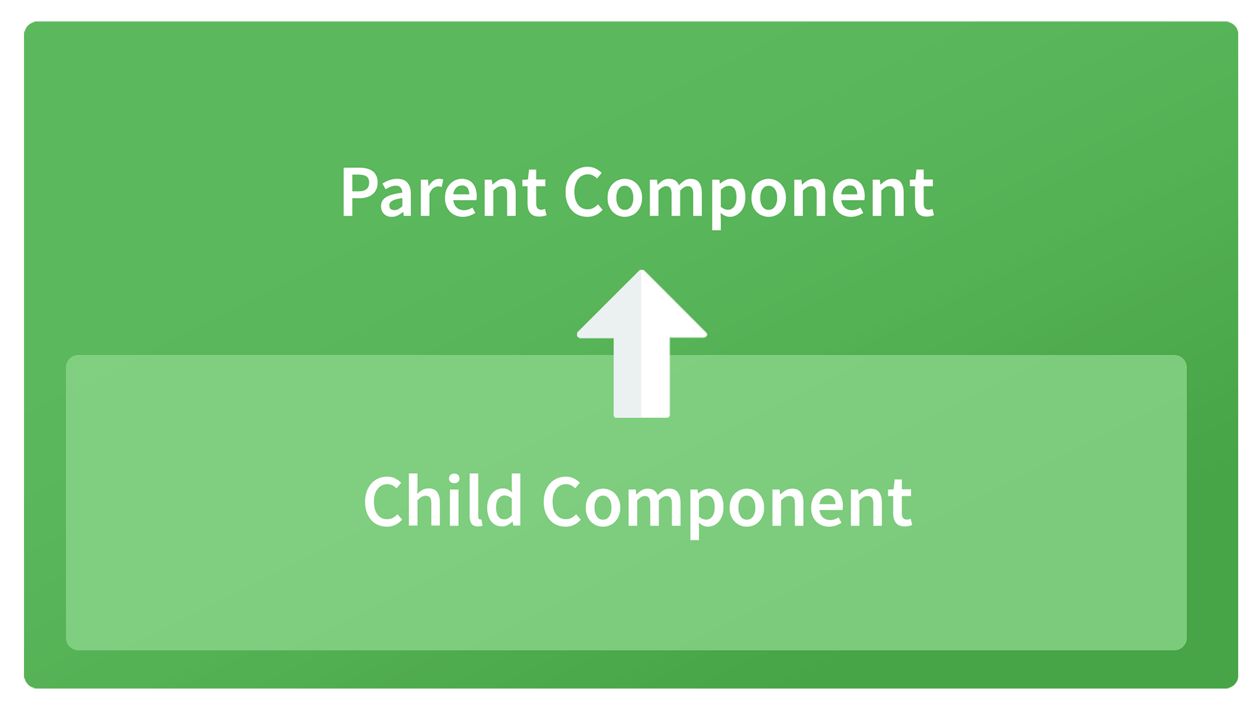

**Child to parent using @ViewChild decorator**  
  
Child component:

import {Component} from '@angular/core';

@Component({

selector: 'app-child',

template:`

<p>{{data}}</p>

`,

styleUrls: ['./child.component.css']

})

export class ChildComponent {

data:string = "Message from child to parent";

constructor() { }

}

Parent Component

import { Component,ViewChild, AfterViewInit} from '@angular/core';

import { ChildComponent } from './../child/child.component';

@Component({

selector: 'app-parent',

template: `

<p>{{dataFromChild}}</p>

` ,

styleUrls: ['./parent.component.css']

})

export class ParentComponent implements AfterViewInit {

dataFromChild: string;

@ViewChild(ChildComponent,{static:false}) child;

ngAfterViewInit(){

this.dataFromChild = this.child.data;

}

constructor() { }

}

In the above example, a property named “data” is passed from the child component to the parent component.  
**@ViewChild** decorator is used to reference the child component as “child” property.  
Using the **ngAfterViewInit** hook, we assign the child’s data property to the messageFromChild property and use it in the parent component’s template.  
  
**Child to parent using @Output and EventEmitter**  
  
In this method, we bind a DOM element inside the child component, to an event ( **click** event for example ) and using this event we emit data that will captured by the parent component:  
  
Child Component:

import {Component, Output, EventEmitter} from '@angular/core';

@Component({

selector: 'app-child',

template:`

<button (click)="emitData()">Click to emit data</button>

`,

styleUrls: ['./child.component.css']

})

export class ChildComponent {

data:string = "Message from child to parent";

@Output() dataEvent = new EventEmitter<string>();

constructor() { }

emitData(){

this.dataEvent.emit(this.data);

}

}

As you can see in the child component, we have used **@Output** property to bind an **EventEmitter**. This event emitter emits data when the button in the template is clicked.  
  
In the parent component’s template we can capture the emitted data like this:

<app-child (dataEvent)="receiveData($event)"></app-child>

Then inside the receiveData function we can handle the emitted data:

receiveData($event){

this.dataFromChild = $event;

}

**14. Explain the concept of Dependency Injection?**

Dependency injection is an application design pattern which is implemented by Angular.  
It also forms one of the core concepts of Angular.  
  
**So what is dependency injection in simple terms?**  
Let’s break it down, dependencies in angular are nothing but services which have a functionality. Functionality of a service, can be needed by various components and directives in an application. Angular provides a smooth mechanism by which we can inject these dependencies in our components and directives.  
So basically, we are just making dependencies which are injectable across all components of an application.

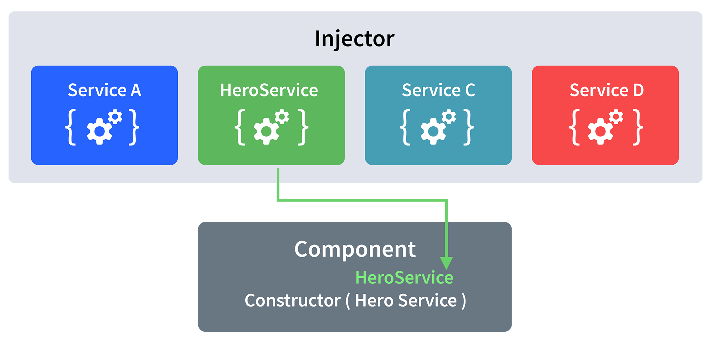

Let’s understand how DI (Dependency Injection) works:  
  
Consider the following service, which can be generated using:

ng g service test

import { Injectable } from '@angular/core';

@Injectable({

providedIn: 'root'

})

export class TestService {

importantValue:number = 42;

constructor() { }

returnImportantValue(){

return this.importantValue;

}

}

As one can notice, we can create injectable dependencies by adding the **@Injectable** decorator to a class.  
  
We inject the above dependency inside the following component:

import { TestService } from './../test.service';

import { Component, OnInit } from '@angular/core';

@Component({

selector: 'app-test',

templateUrl: './test.component.html',

styleUrls: ['./test.component.css']

})

export class TestComponent implements OnInit {

value:number;

constructor(private testService:TestService) { }

ngOnInit() {

this.value = this.testService.returnImportantValue();

}

}

One can see we have imported our TestService at the top of the page. Then, we have created an instance inside the constructor of the component and implemented the **returnImportantValue** function of the service.  
  
From the above example, we can observe how angular provides a smooth way to inject dependencies in any component.

**15. Explain MVVM architecture**

MVVM architecture consists of three parts:  
  
1.Model  
2.View  
3. ViewModel

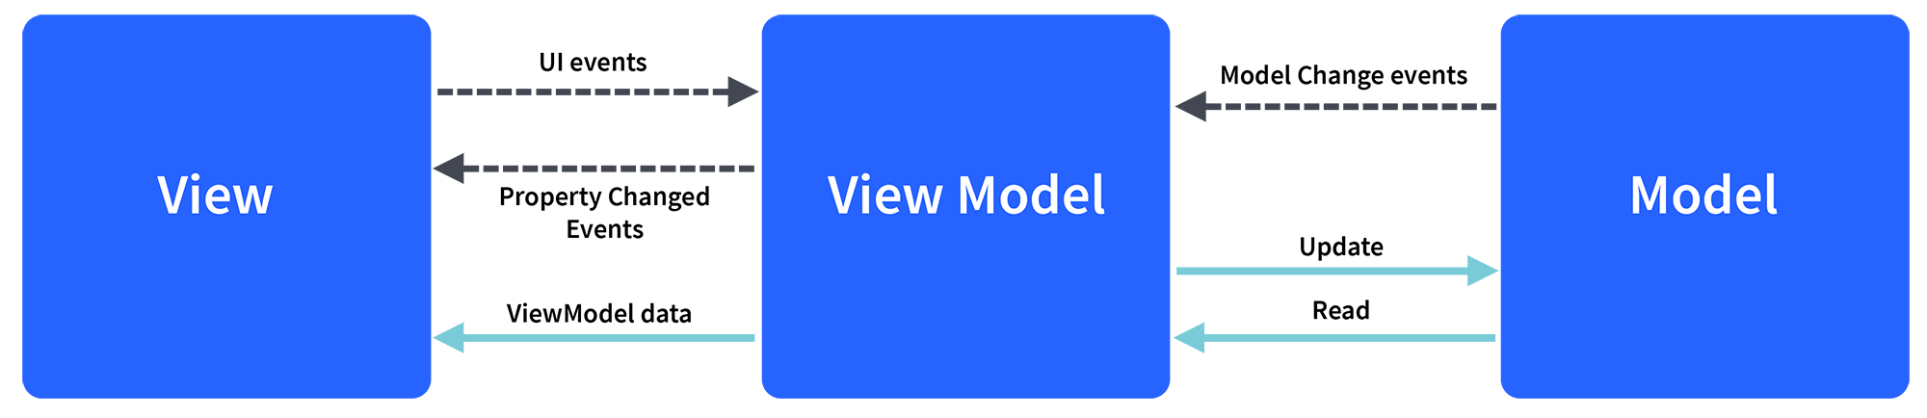

Model contains the structure of an entity. In simple terms it contains data of an object.  
View is the visual layer of the application. It displays the data contained inside the Model. In angular terms, this will be the HTML template of a component.  
  
ViewModel is an abstract layer of the application. A viewmodel handles the logic of the application. It manages the data of a model and displays it in the view.  
View and ViewModel are connected with data-binding (two-way data-binding in this case). Any change in the view, the viewmodel takes a note and changes the appropriate data inside the model.